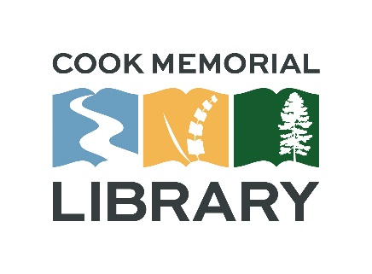**Cook Memorial Library Commission**

**Regular Meeting Agenda**

**Thursday, March, 17 2022 @4:00pm**

**Location: Cook Memorial Library Community Room**

1. Call to order
   1. Meeting called to order at:
2. Additions/deletions from the agenda
3. Approval of minutes
   1. November 18, 2021
   2. December 16, 2021
   3. January 20, 2022 (meeting cancelled)
4. Public comments

a. State Library of Oregon update – Jennie Tucker

1. Reports
   1. Director’s report
   2. Activities updates
2. New Business
3. Correspondence
4. Agenda items for next meeting
5. Adjournment
   1. Meeting adjourned at: